BIA1B Business and Information Systems Architecture
MGMT-6134-24S Capstone Project

Connecting XYZ: Modernizing Web Presence and Marketing Integration

Milestone 3


Professor Mona Abou Taka
Professor Marc Bueno
Professor Georgi Ivanov

Group 1: BIA Falcon Synergy

Section 32
Jim Raynor 1111111
Sarah Kerrigan 1111111
Amit Patel 1111111
Section 31
Amit Kaur 1111111

Table of Contents
1. Milestone Summary 5
2. System Architecture 6
3. Entity-Relationship Diagram 7
4. Data Dictionary 8
5. Embedded Services and SQL Functions 12
5.1. Google Maps 12
5.2. HubSpot Form 13
5.3. PHP/SQL functions 14
6. Draft of Test Cases 20
7. Draft of Deployment Diagram 21
8. Updated UI / UX Prototypes 23
8.1. Main Website 23
8.2. Admin Portal 40
9. References 48
10. Appendix 49

Table of Figures
Figure 1: System Architecture 6
Figure 2: Entity-Relationship Diagram 7
Figure 3: Google Maps – Embed a map generation 12
Figure 4: Google Maps – Embed a map result 13
Figure 5: HubSpot Form – Embed code 14
Figure 6: phpMyAdmin Connect Page 15
Figure 7: user_credentials table in the database 17
Figure 8: Error Message if Email already exists 17
Figure 9: Error Message if Username already exists 18
Figure 10: Admin Panel welcome screen – Admin view 18
Figure 11: Admin Panel welcome screen – Marketing view 19
Figure 12: Case Studies View in Admin Panel 20
Figure 13: Deployment Diagram 21
Figure 14: Website Header 23
Figure 15: Website Footer 23
Figure 16: Homepage - Carousel 25
Figure 17: Homepage - Flip Cards 26
Figure 18: Homepage - abc™ 26
Figure 19: Homepage – Custom Machines 27
Figure 20: Homepage – Solutions and Services, Partner 28
Figure 21: Homepage - Testimonials 29
Figure 22: abc™ Page 1 30
Figure 23: abc™ Page 2 30
Figure 24: Custom Machines Page 1 31
Figure 25: Custom Machines Page 2 32
Figure 26: Case Studies Page 1 33
Figure 27: Case Studies Page 2 34
Figure 28: Services Page 1 35
Figure 29: Services Page 2 35
Figure 30: News and Events Page 1 36
Figure 31: News and Events Page 2 37
Figure 32: News and Events Page 3 37
Figure 33: Contact Us Page - Form 38
Figure 34: Contact Us Page – Google Maps 39
Figure 35: Admin Login Page 40
Figure 36: Password recovery page 41
Figure 37: Reset password page 42
Figure 38: Admin panel main page – Admin view 43
Figure 39: Admin panel main page – Marketing view 44
Figure 40: Users table – Available only for admin view 44
Figure 41: Case Studies table 45
Figure 42: User creation form – Available only for admin view 46
Figure 43: Case studies creation form 54
Figure 44: Careers Table 55
Figure 45: Testimonials Table 56
Figure 46: News and Events Table 57
Figure 47: Gantt Milestone 3 58
Figure 48: Gantt details 59

Table of Tables
Table 1: Data Dictionary – User table 8
Table 2: Data Dictionary – User Credentials 9
Table 3: Data Dictionary – User Role 9
Table 4: Data Dictionary – Case Study 9
Table 5: Data Dictionary - Testimonial 10
Table 6: Data Dictionary - Careers 10
Table 7: Data Dictionary – Support Ticket 11
Table 8: Data Dictionary – News and Events 11

Milestone Summary

During this milestone, we finalized the system architecture, ER Diagram, Data dictionary and UI&UX design. We evaluated if our solution required API functions and started designing our Test cases and Deployment diagram. In the following table, you can find the status of the project.
.
Event | Title | Start | Due | Status
Milestone 1 | Inception | May-06 | May-31 | Completed
Milestone 2 | Analysis | June-01 | June-21 | Completed
Milestone 3 | Design | June-22 | July-19 | Completed
Milestone 4 | Development | July-20 | Aug.-09 | Not Started
Final | Evaluation | Aug.-10 | Aug.-16 | Not Started
Table 1: Milestones Summary and Status

At this stage of the capstone project, all required steps for Milestone 3 completion have been performed and documented, which are:
- ER Diagram
- Data dictionary
- UI&UX design
- Draft of:
- System Architecture
- Entity-Relationship diagram (Physical Data Model)
- Data Dictionary
- UI/UX Prototypes

System Architecture
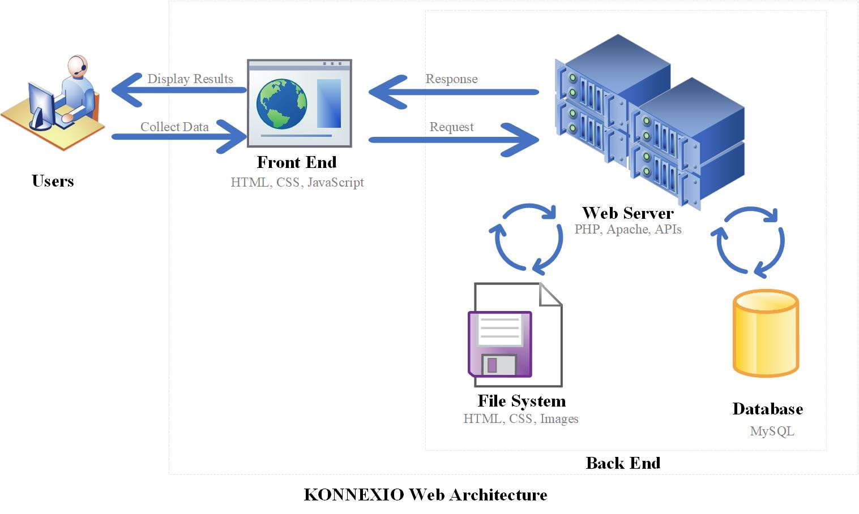
Figure 1: System Architecture

Our system architecture remains largely the same as what we presented in the last milestone report. The diagram provides an overview of the new website’s system architecture. This includes the roles and interactions of users, the front end, the web server, the file system, and the database.

- Users: The end-users interact with the system through a web browser or other client application. They collect data (input) and receive/display results (output).
- Front End: This is the client side of the web application, built with HTML, CSS, and JavaScript. The front end gathers user input and sends it to the web server. Also, it receives data from the server and presents it to the user.
- Web Server: The server side that handles the logic, processing requests, and serving responses. It uses PHP, JavaScript, and APIs. These technologies will be running in a Linux operating system.
- Request Handling: Processes incoming requests from the front end.
- Response Generation: Generates appropriate responses to send back to the front end.
- File System and Database Interaction: Interacts with the file system and database to retrieve and store data.
- File System: A storage system for static content like HTML files, CSS files, and images. It stores and serves static files required by the front end.
- Database: A MySQL database that stores dynamic data used by the web application. It stores structured data that can be queried and manipulated by the web server.

Entity-Relationship Diagram

The ER diagram represents the structure of the website’s and admin panel’s database. It depicts how the elements are linked to user accounts, highlighting the relationships between these entities and how they interact within the system.

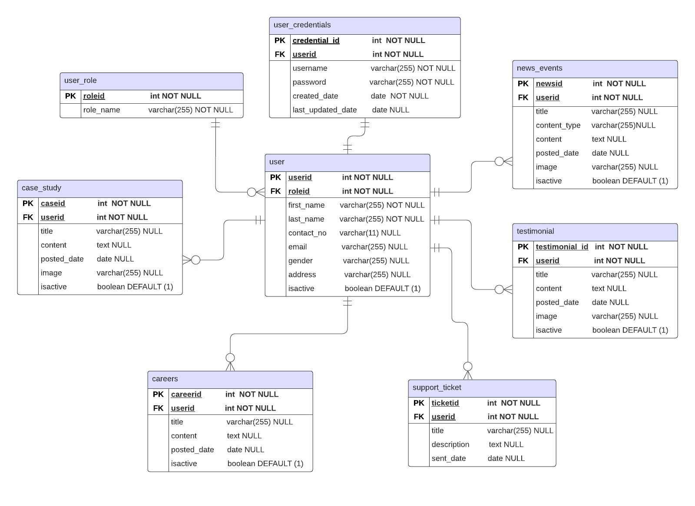
Figure 2: Entity-Relationship Diagram

We are using the below tables for dynamic content management. All these tables have zero or many relationships with the user table and the user table has the one and only one relationship with the specific table. In simple words, only one user is responsible for a specific record in the dynamic table, there can be users without adding contents to these dynamic tables, and there can be a user with multiple records in these dynamic tables.
- news_events table
- careers table
- testimonial table
- case_study table

We are using a master table named, user_role to maintain the different types of roles. This table has zero or many relationships with the user table and the user table has one and only one relationship with the user_role table. In simple words, only one role can be assigned to a one-user account. Indeed, there’s another separate table called, user_credentials for storing users’ credential data. This table has one and only one relationship with the user table. This ensures that there are no duplicates for the user accounts’ emails and username fields. In this table we are encrypting the password field to enhance the security of our database.

On the website, there’s a form for creating support tickets to the company through the Contact Us page. Those data are saved in the support_ticket table and then the admin can view these details through the admin panel page. We ensure that all these tables are in the 3rd Normal Form (3NF).

Data Dictionary

user
Column Name | Data Type | Constraints | Description
userid | int | PK, NOT NULL | Unique identifier for user
roleid | int | FK, NOT NULL | Role identifier
first_name | varchar(255) | NOT NULL | First name of the user
last_name | varchar(255) | NOT NULL | Last name of the user
contact_no | varchar(11) | NULL | Contact number of the user
email | varchar(255) | NULL | Email address of the user
gender | varchar(255) | NULL | Gender of the user
address | varchar(255) | NULL | Address of the user
isactive | boolean | DEFAULT (1) | User active status
Table 1: Data Dictionary – User table

user_credentials
Column Name | Data Type | Constraints | Description
credential_id | int | PK, NOT NULL | Unique identifier for credentials
userid | int | FK, NOT NULL | User identifier
username | varchar(255) | NOT NULL | Username for login
password | varchar(255) | NOT NULL | Password for login
created_date | date | NOT NULL | Date when credentials were created
last_updated_date | date | NULL | Date when credentials were last updated
Table 2: Data Dictionary – User Credentials

user_role
Column Name | Data Type | Constraints | Description
roleid | int | PK, NOT NULL | Unique identifier for role
role_name | varchar(255) | NOT NULL | Name of the user role
Table 3: Data Dictionary – User Role

case_study
Column Name | Data Type | Constraints | Description
caseid | int | PK, NOT NULL | Unique identifier for case study
userid | int | FK, NOT NULL | User identifier who submitted the case study
title | varchar(255) | NULL | Title of the case study
content | text | NULL | Content of the case study
posted_date | date | NULL | Date when case study was posted
image | varchar(255) | NULL | Image related to the case study
isactive | boolean | DEFAULT (1) | Case study active status
Table 4: Data Dictionary – Case Study

testimonial
Column Name | Data Type | Constraints | Description
testimonial_id | int | PK, NOT NULL | Unique identifier for testimonial
userid | int | FK, NOT NULL | User identifier who submitted the testimonial
title | varchar(255) | NULL | Title of the testimonial
content | text | NULL | Content of the testimonial
posted_date | date | NULL | Date when testimonial was posted
image | varchar(255) | NULL | Image related to the testimonial
isactive | boolean | DEFAULT (1) | Testimonial active status
Table 5: Data Dictionary - Testimonial

careers
Column Name | Data Type | Constraints | Description
careerid | int | PK, NOT NULL | Unique identifier for career opportunity
userid | int | FK, NOT NULL | User identifier who posted the career opportunity
title | varchar(255) | NULL | Title of the career opportunity
content | text | NULL | Content of the career opportunity
posted_date | date | NULL | Date when career opportunity was posted
isactive | boolean | DEFAULT (1) | Career opportunity active status
Table 6: Data Dictionary - Careers

support_ticket
Column Name | Data Type | Constraints | Description
ticketid | int | PK, NOT NULL | Unique identifier for support ticket
userid | int | FK, NOT NULL | User identifier who submitted the support ticket
title | varchar(255) | NULL | Title of the support ticket
description | text | NULL | Description of the support ticket
sent_date | date | NULL | Date when support ticket was sent
Table 7: Data Dictionary – Support Ticket

news_events
Column Name | Data Type | Constraints | Description
newsid | int | PK, NOT NULL | Unique identifier for news/event
userid | int | FK, NOT NULL | User identifier who posted the news/event
title | varchar(255) | NULL | Title of the news/event
content_type | varchar(255) | NULL | Type of content (e.g., news, event)
content | text | NULL | Content of the news/event
posted_date | date | NULL | Date when news/event was posted
image | varchar(255) | NULL | Image related to the news/event
isactive | boolean | DEFAULT (1) | News/event active status
Table 8: Data Dictionary – News and Events

Embedded Services and SQL Functions

Google Maps
On the Contact Us page, we have implemented an iFrame using embedded code to integrate with Google Maps. This functionality enhances the user experience by providing an interactive map to easily locate Xyz’s offices in London, ON.

We have embedded the below code in the Contact page (Google, n.d.):
<iframe src="https://www.google.com/maps/embed?pb=!1m18!1m12!1m3!1d2917.5109869850908!2d-81.17708012437848!3d43.009630593817604!2m3!1f0!2f0!3f0!3m2!1i1024!2i768!4f13.1!3m3!1m2!1s0x882eed3828696603%3A0x8995d1593b38c989!2sXyz%20Inc.!5e0!3m2!1sen!2sca!4v1721086683724!5m2!1sen!2sca" allowfullscreen></iframe>

Steps for implementation of the google maps:
- Opened Google Maps.
- Found the location by entering the address or name in the search bar.
- Clicked on the "Share" button.
- Clicked on the "Embed a map" tab in the window that popped up.
- Customized the map size as needed and copied the HTML iframe code provided.
- Opened the HTML file in a code editor.
- Include the iframe code in the html page where the map is expected to be visible.

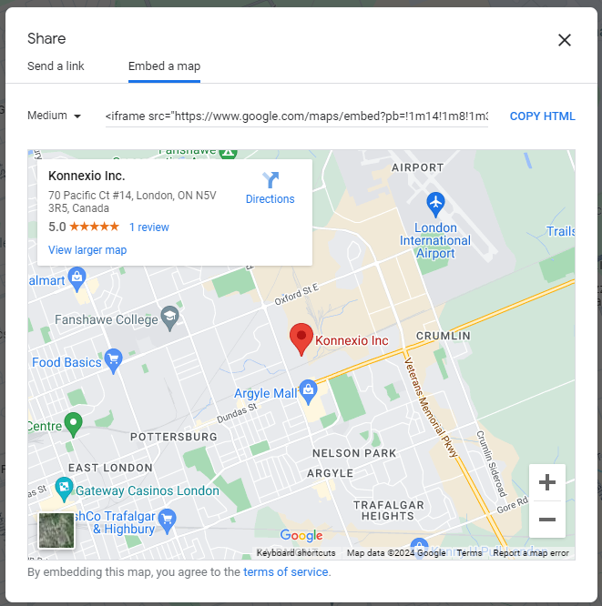
Figure 3: Google Maps – Embed a map generation

The following image showcases the embedded map on our website.
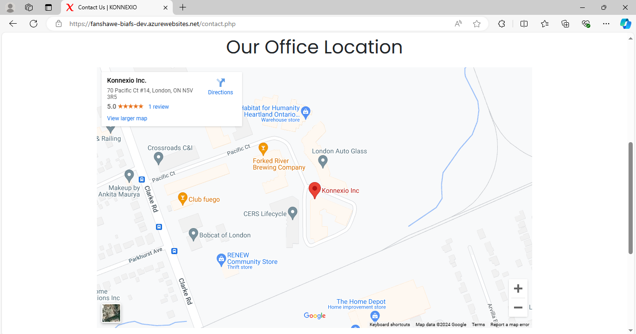
Figure 4: Google Maps – Embed a map result

HubSpot Form
The primary objective of the client is to increase their sales. By enabling users to submit a form on the company's Contact Us page and get in touch with them directly, we provide an IT solution to support this business goal. To achieve this, a form integrated with XYZ’s CRM (HubSpot) will be embedded on the website.
This form will be generated using HubSpot capabilities, which ensures smooth integration and enhances the user experience by facilitating easy lead capture and traceability in the customer journey. Through this connection, XYZ can communicate more easily and conveniently with its leads, helping the company nurture them and address inquiries more efficiently.

Below you can find the code generated (HubSpot, 2024):

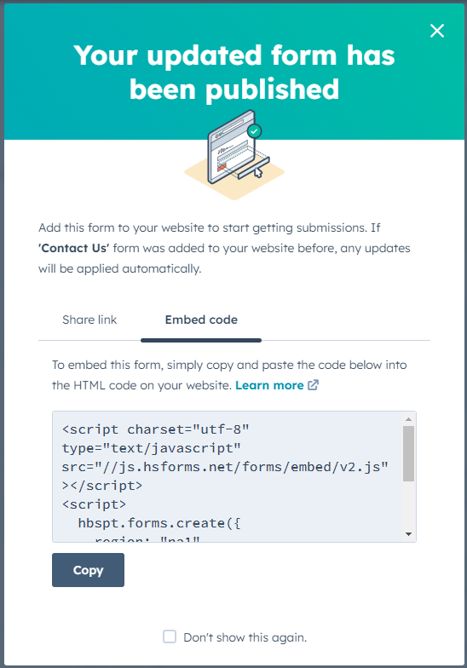
Figure 5: HubSpot Form – Embed code

PHP/SQL functions

    - Secure SQL Connection to the Database
To maintain a highly secure database design for the system, we have created a separate admin account with the least privileges approach without using the default root admin account. By default, the root admin account is enabled to connect without a password, and this contains all the privileges for the database. Due to these low-security issues, we have configured a new admin account named “xyz” with a highly secured password to log in to the database. In there, we have limited access levels like dropping tables, dropping databases and viewing system configuration details.

To set up the phpMyAdmin admin account we have changed the below configurations settings in the “config.inc.php” file, which is available in the below path, C:\xampp\phpMyAdmin in our local machine.

$cfg['Servers'][$i]['auth_type'] = 'cookie'; /* Default is 'config' */
$cfg['Servers'][$i]['user'] = 'XYZ'; /* Default is 'root' */
$cfg['Servers'][$i]['password'] = '<<our password>>'; /* Default is '' */
$cfg['Servers'][$i]['AllowNoPassword'] = false; /* Default is true */
$cfg['blowfish_secret'] = 'a rAnd0m str11!11111!11!nG'; /* New Configuration*/
$cfg['Servers'][$i]['only_db'] = array('XYZ'); /* New Configuration */

After all these configuration changes, we are connecting to our system’s database using the below welcome page.

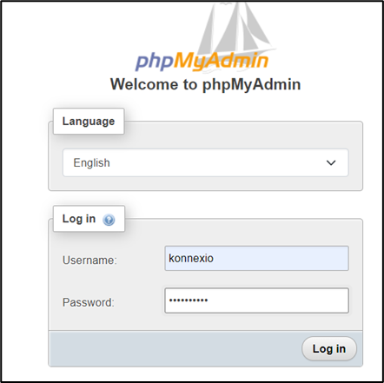
Figure 6: phpMyAdmin Connect Page

    - PhpMyAdmin Database Connection to the Website and Admin Panel
We are using a separate file to connect the database tables’ data to both the website and the admin panel using a php file called “connection.php”. Here we are using server-side php variables to handle the database details using $servername, $username, $password and $dbname and performing the connection using $conn variable as shown below.

$conn = new mysqli($servername, $username, $password, $dbname);

To create the connection, we are using the mysqli() class without using the mysql() class. Below are the reasons for selecting MYSQLi for our connection script. (Vincy, 2022)
- pupports prepared statements
- provides both procedural and object-oriented interfaces
- provides enhanced security and improved debugging
- supports transactions through API

Error handling during connection determines whether an error occurs while attempting to connect. If there is a problem, the error's description can be found in connect_error. If the connection fails, this function ends the script and prints an error message.

    - User Input Forms
There is a very common attack called SQL Injection Attack happening in most websites due to least security mechanisms. An attacker can interfere with an application's database queries via a web vulnerability known as SQL injection (SQLi). Because of this, an attacker might be able to see data that they would not typically be able to access. Any other data that the application has access to or that is owned by other users may fall under this category. An attacker can frequently alter or remove this data, changing the application's behaviour or content persistently. If an attacker inputs something like ' OR '1'='1, the query could be manipulated to return all rows, potentially compromising the security of your database. (PortSwigger, n.d.)

To prevent from this attack, we are using prepared statements with bound parameters without directly sending the user inputs to the SQL queries. Below is an example where we have used prepared statements for high-security features.

$stmt = $conn->prepare("SELECT user_credentials.userid, username, first_name, last_name, password, role_name, user_role.roleid
FROM user_credentials
JOIN user ON user_credentials.userid = user.userid
JOIN user_role ON user.roleid = user_role.roleid
WHERE username=? AND isactive = 1");
$stmt->bind_param("s", $username);

- Preparation Phase - Rather than directly integrating user inputs, placeholders (?) are used in the SQL query definition. Inputs are now being treated as parameters by the database instead of executable code.
- Binding Phase - $username value is bound to the placeholder using bind_param("s", $username). The parameter's type is indicated as a string by the "s". "I" stands for integer, "d" for double, and "b" for blob are some other potential types.
- Execution Phase - The database engine makes sure that user inputs are handled as data during the execution of the statement, not as a component of the SQL command. This stops any malicious input from changing the query structure as intended.

    - Data Validations using PHP
- Password_Hash() Function - For the admin panel, we are using password_hash() function to store passwords in our database table. This method ensures that our users’ confidential data are kept safe as even the admin also not able to retrieve passwords by accessing the database. We are using this security feature in the signup process as below.

$hashed_password = password_hash($passwordf, PASSWORD_DEFAULT);

The below figure shows how the passwords are saved to the database table from the admin panel create user page.

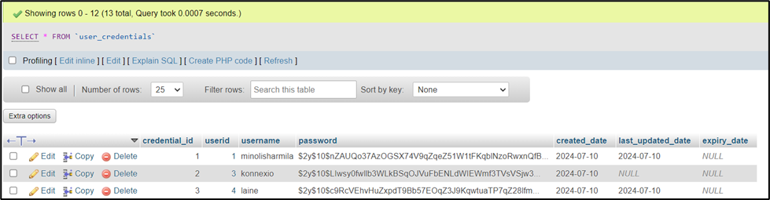
Figure 7: user_credentials table in the database

The below benefits can be obtained by using this validation method (Lucid Team, 2023):
- passwords are automatically salted to thwart precomputed attacks.
- utilizing computationally costly hashing to increase the difficulty of brute-force attacks.
- giving password verification a straightforward and safe method.

- Email and Username Validation - In the admin panel we ensure that one and only one email and username can be registered. For that, we are restricting the user to registering already existing emails and usernames by displaying error messages in the signup process.

// Check if email already exists
$stmt = $conn->prepare("SELECT * FROM user WHERE email = :email");
$stmt->bindParam(':email', $email);
$stmt->execute();

// Check if username already exists
$stmt1 = $conn->prepare("SELECT user_credentials.* FROM user_credentials
JOIN user ON user_credentials.userid = user.userid
WHERE username = :username");
$stmt1->bindParam(':username', $usernamef);
$stmt1->execute();

Below are the error messages which are generated in the admin panel’s signup process due to the above validations.

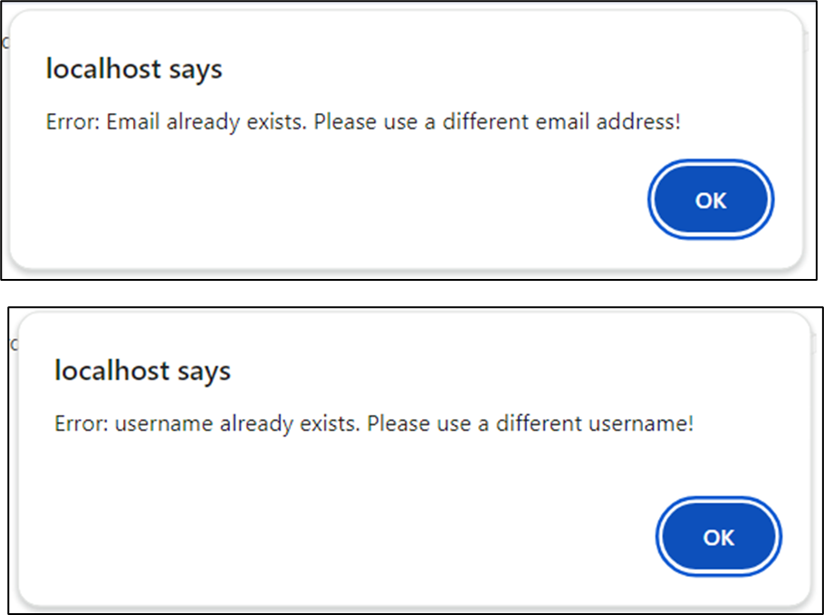
Figure 8: Error Message if Email already exists

Figure 9: Error Message if Username already exists

- Access Control - In the admin panel we are using an access control mechanism using different roles via user_role table. Here we have given full access to the admin panel only for the role named admin. We are hiding the features like new user tab, view admin panel home content, support ticket tab and user management tab from the other user roles using this mechanism.

Below is an example scenario we have used the access control mechanism to open the New User tab only for the admin role (roleId = 1) from all pages in the admin panel.

<?php if (isset($_SESSION['roleid']) && htmlspecialchars($_SESSION['roleid']) == 1): ?>
<li class="nav-item">
<a class="nav-link" href="UsersNew.php">
<i class="fas fa-fw fa-user-plus"></i>
<span>New User</span>
</a>
</li>
<?php endif; ?>

Below is the admin panel home page, when an admin and marketing user logs into the admin panel.

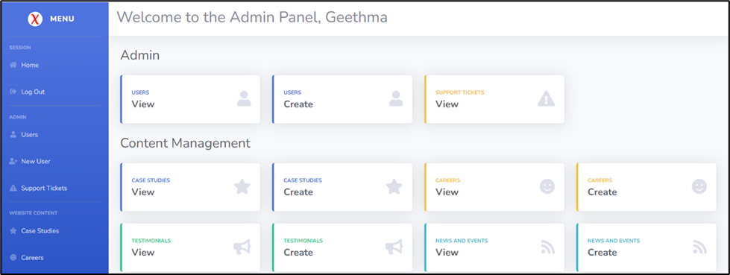
Figure 10: Admin Panel welcome screen – Admin view

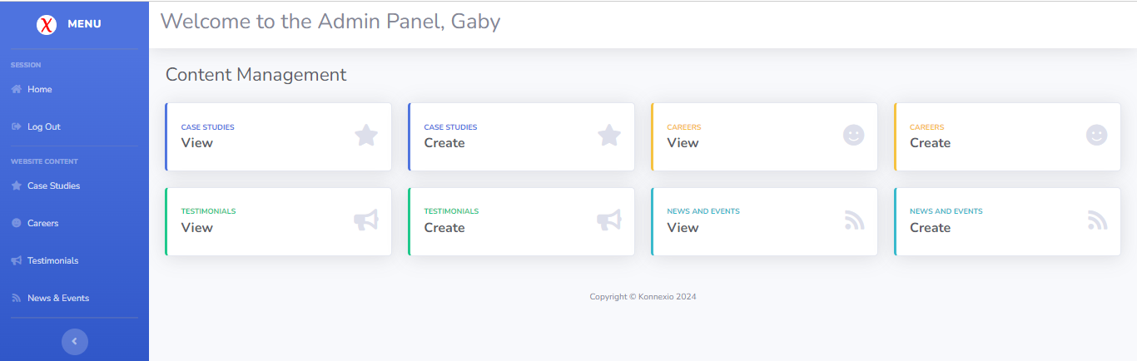
Figure 11: Admin Panel welcome screen – Marketing view

    - Session Control
Browsers and websites use the "stateless" HTTP protocol. This indicates that no user or session-related data is stored by the server. However, web applications require a mechanism to access data or identify users across sessions (Palacios, 2023).
When the admin accidentally fills the signup form details with an already existing email or email user, he gets an error stating that the email or username already exists. At that time, form data is stored in the session using the key 'form_data'. When the admin clicks ok in the error message, the signup page loads with the pre-filled form fields. Finally, after all these steps, when the user clicks the Logout button, all the saved session details are destroyed.

- Starting the session - Before any output is transmitted to the browser, this must be called at the start of the script. We are validating if a session is already started to avoid concurred sessions.
<?php if (session_status() === PHP_SESSION_NONE) {
session_start();
}
- ?> Store data in the session – In the signup process, we are using this mechanism.
$_SESSION['form_data'] = $_POST;
- This destroys the session on the server.
session_destroy();

    - Dynamic Content Management
For both the website and admin panel, we are using the Boolean type “isactive” column to manage dynamic content. By default, we set all the new contents are set to “isactive = 1” in the tables and the website or the admin panel loads content accordingly. Using this column, we are giving access to the admin panel to reactivate or unpublish contents and deactivate or reactivate user accounts. All the changed content is going to be loaded to the website automatically soon after the admin panel’s changes.

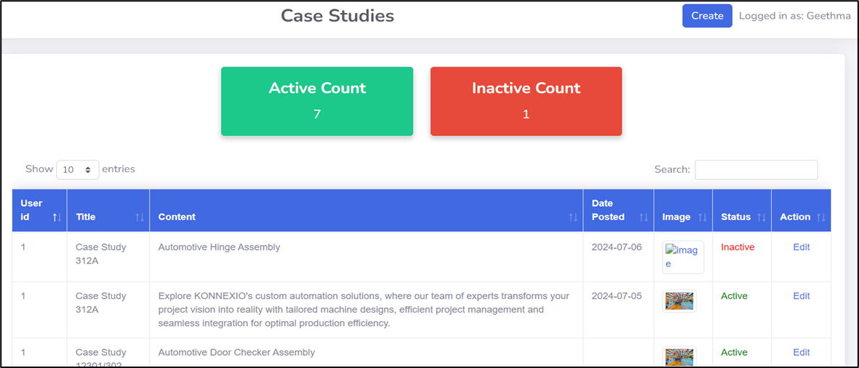
Figure 12: Case Studies View in Admin Panel

Draft of Test Cases

We have drafted a comprehensive set of test cases to ensure the quality and functionality of our project. These test cases are designed to cover various aspects of the application, including the User Interface, and core functionalities through unit tests.

The detailed test cases are provided in the Appendix Section 10.1 of this report. Below is a brief overview of the test case groups:

  - UI/UX Test Cases

- Homepage: Verifies the functionality of interactive elements like carousels, buttons, and hover effects.
- Header and Footer: Verifies the functionality of interactive elements like carousels, buttons, and hover effects.
- Admin Panel: Checks the functionality of the navbar and dashboard items, including item redirection and expand/collapse features.

  - Unit Test Cases

- User Logging: Validates the user login process, including both successful and unsuccessful attempts.
- User Managing: Verifies viewing, updating, and deleting user information.
- User Creating: Ensures the process of new user creation, including input validation and data submission.
- Content Managing: Checks the functionality of viewing, editing, updating, and deleting content.
- Content Creating: Verifies the process of creating new content, including input validation and data submission.

  - Future Work
While the test cases are listed in section 10.1 of the appendix, the columns for "Actual Result" and "Status (Pass/Fail)" in the test cases are currently left blank.

The next milestone will involve the actual execution of these tests and the documentation of their outcomes, ensuring our application meets the highest standards of quality and performance.

Draft of Deployment Diagram
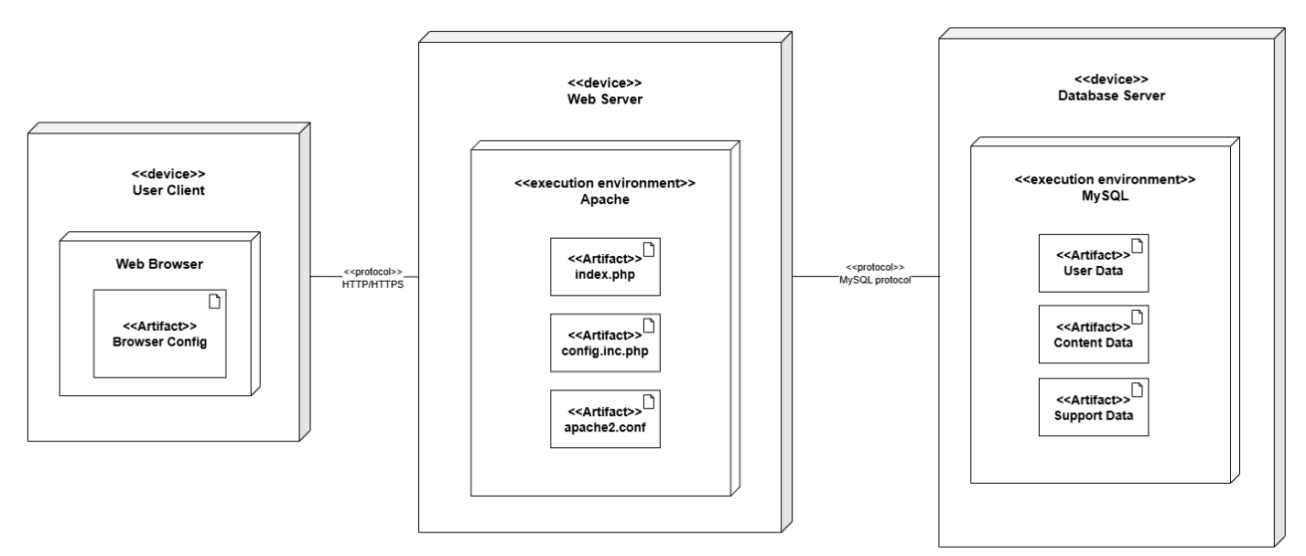
Figure 13: Deployment Diagram

The deployment diagram illustrates the physical deployment of artifacts on nodes for our project. It highlights the interaction between different devices and the distribution of components and artifacts across these devices.

  - Nodes and Components
User Client:
- Device: User Client
- Components:
  - Web Browser: The interface through which users interact with the web application.
- Artifacts:
  - Browser Config: Configuration files for the web browser, ensuring optimal performance and compatibility.

Web Server:
- Device: Web Server
- Execution Environment: Apache
- Components:
  - PHP Application: The core of our web application, responsible for handling requests and serving dynamic content.
    - Application Logic: The business logic of the application.
    - Middleware: Intermediary processing logic.
    - Route Handler: Handles routing of incoming requests to appropriate endpoints.
- Artifacts:
  - index.php: The main entry point of the PHP application.
  - config.inc.php: Configuration file containing settings and parameters for the application.
  - apache2.conf: Configuration file for the Apache web server, specifying server settings and behavior.

Database Server:
- Device: Database Server
- Execution Environment: MySQL
- Components:
  - MySQL Database: The database system used for storing and managing application data.
    - User Data: Data related to user accounts and profiles.
    - Content Data: Data pertaining to the content managed by the application.
    - Support Ticket Data: Data related to support tickets submitted by users.
- Artifacts:
  - User Data: Schema and data files for user information.
  - Content Data: Schema and data files for content management.
  - Support Data: Schema and data files for support tickets.

  - Communication Protocols
- HTTP/HTTPS: The communication protocol between the User Client and the Web Server, used for transmitting web pages and user requests securely.
- MySQL Protocol: The protocol used for communication between the Web Server and the Database Server, enabling data queries and transactions.

Updated UI / UX Prototypes

Main Website

    - Header and Footer

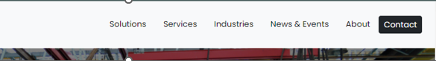
Figure 14: Website Header
Header
- Branding:
  - Logo Placement: The logo "XYZ" is prominently displayed on the left side, a standard practice that helps users quickly identify the brand.
  - Visual Appeal: The "X" in the logo is highlighted in red, creating a focal point and adding visual interest.
- Navigation:
  - Menu Items: The navigation menu is horizontally aligned, listing key sections like Solutions, Services, Industries, News & Events, About, and Contact.
  - Ease of Access: Each menu item is clearly labelled and easily accessible, ensuring users can navigate to different website sections effortlessly.
  - Call to Action: The "Contact" button is prominently displayed on the far right, contrasting with the rest of the menu items, making it stand out for users who may want to get in touch.
- Design Consistency:
  - Color Scheme: The header maintains a consistent colour scheme with the brand's colours, ensuring visual harmony.
  - Typography: The fonts used are clean and readable, enhancing the overall user experience.

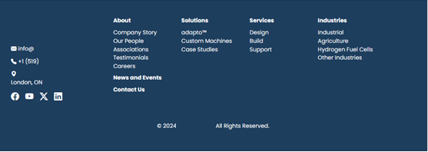
Figure 15: Website Footer

Footer
- Information Architecture:
  - Section Breakdown: The footer is divided into distinct sections: About, Solutions, Services, Industries, News and Events, and Contact Us.
  - Contact Information: Essential contact details like email, phone number, and address are listed, making it easy for users to reach out.
  - Social Media Icons: Icons for Facebook, LinkedIn, YouTube, and Instagram are included, promoting the brand's social media presence.
- Accessibility:
  - Footer Links: The links in the footer are well-organized and easily navigable, helping users find additional information quickly.
  - Readability: The text is white on a dark blue background, which provides a high contrast, improving readability.
- Visual Design:
  - Color Scheme: The footer uses a dark background which contrasts with the header, visually separating the content areas.
  - Typography and Spacing: The fonts and spacing are consistent and clear, contributing to an aesthetically pleasing and functional design.
- Legal Information:
  - Copyright Notice: The footer includes a copyright notice, ensuring users are aware of the legal aspects related to the content and branding.

UX Considerations
- User Journey:
  - Intuitive Navigation: Both the header and footer provide clear paths for users to navigate the website, contributing to a smooth user journey.
  - Consistency: The consistent design and color scheme between the header and footer create a cohesive experience.
- Accessibility:
  - Contrast and Readability: High contrast in both the header and footer improves accessibility for users with visual impairments.
  - Ease of Contact: The prominent contact details in both the header and footer ensure users can easily find ways to get in touch, enhancing the overall user experience.
- Responsive Design:
  - Adaptability: The design elements in both the header and footer are likely to be responsive, ensuring a good user experience across different devices and screen sizes.

    - Index / Homepage
The homepage for Xyz is where we showcase the company’s innovative solutions and services across various industries. The company’s offerings are sketched through the various sections on the page so the user can learn more about the company.

Main Carousel

Figure 16: Homepage - Carousel

The main carousel features a rotating series of high-quality images showcasing the company’s most significant work and projects. Each image is accompanied by text overlays with brief descriptions or slogans that highlight the company's core competencies and achievements. Users are immediately engaged by the dynamic visuals and can easily navigate through the carousel using arrows or swipe functionality. Prominent CTAs like "Learn More" guide users to more detailed information, ensuring a smooth and engaging experience.

Flip Cards – Specialized Industries

Figure 17: Homepage - Flip Cards

This section presents a grid of flip cards, each representing a different industry the company specializes in. The front side of each card displays the industry name with an icon or image, while the back side reveals a brief description of the company's expertise in that sector. Users can hover or click to flip the cards, adding an interactive element that makes exploring industries both engaging and informative. This intuitive design helps users quickly discover areas of interest.

Image Sections – Abc Technology & Custom Machines

Figure 18: Homepage - abc™

Figure 19: Homepage – Custom Machines

Showcasing high-resolution images, this section highlights Abc Technology and Custom Machines in action. Accompanying text explains the technology’s features, benefits, and market position. Users are drawn in by the striking visuals and can easily understand the value of Abc Technology and Custom Machines through concise descriptions. The strategically placed CTA encourages users to explore further details, facilitating an informative and user-friendly experience.

Solutions and Services Section

Figure 20: Homepage – Solutions and Services, Partner

This section displays a series of image boxes representing different solutions and services offered by the company. Each box includes an image and a title, making it easy for users to identify and learn about specific offerings. Clicking on a box redirects users to detailed pages, creating a seamless navigation experience and allowing users to quickly find the information they need about the company’s services.

Partners Section
The Partners section features logos of various companies with whom the company collaborates, organized in a clean grid format. This layout not only builds credibility but also provides users with a visual representation of the company’s network. Clickable logos lead to partner websites or detailed partnership pages, offering users an easy way to explore and understand the company’s professional relationships.

Figure 21: Homepage - Testimonials

Carousel – Testimonials
This smaller, horizontal scrolling carousel displays user testimonials, complete with names and positions, alongside short excerpts of their positive feedback. The scrolling functionality allows users to effortlessly browse through various testimonials, providing social proof and enhancing trust in the company’s services. The position or role of the user along with the company name adds authenticity, making the testimonials more relatable and impactful.

This homepage design provides a comprehensive overview of Xyz’s capabilities and offerings, with each section carefully crafted to ensure a smooth and engaging user experience. The interactive elements and intuitive layout are designed to facilitate easy navigation and meaningful interaction, enhancing the site's overall usability.

    - Solutions - abc™

Users can navigate to the abc™ page by following the below navigation path:
- Solutions -> abc™

The abc™ page features a sleek and professional design that highlights the unique features of Abc Technology. The layout includes a standardized header and footer, to ensure consistency across the site. The main content area is designed with a clean, minimalistic interface for easy navigation.

Figure 22: abc™ Page 1

Figure 23: abc™ Page 2

Key elements include:
- Dynamic Background Image: The page utilizes JavaScript to display a dynamic background image that changes based on user interactions or predefined conditions. This enhances visual appeal and keeps the content engaging.
- Content Sections: Detailed descriptions, high-quality images, and diagrams are used to showcase the technology’s capabilities and benefits. These elements are organized into sections with smooth scrolling effects implemented via JavaScript for a seamless user experience.
- Interactive Features: JavaScript is also used for interactive features such as image sliders and hover effects, providing an engaging way for users to explore the content.
- Consistent Styling: The use of consistent fonts, colours, and spacing throughout the page enhances readability and visual appeal, reflecting the owner’s pride in the trademarked technology. CSS is employed to maintain this consistency and provide a polished look.

The static nature of the page ensures quick loading times, while the interactive elements and dynamic background image keep users engaged and provide a modern web experience.

    - Custom Machines

Figure 24: Custom Machines Page 1

Figure 25: Custom Machines Page 2

Users can navigate to the Custom Machines page by following the below navigation path:
- Solutions -> Custom Machines

The hero section of the Custom Machine’s page captivates users with a large, segmented image showcasing different aspects of custom machines, accompanied by a concise description and a prominent "Contact Us" button. The vertical side navigation menu within the main content area allows users to switch between various subsections effortlessly, ensuring a seamless browsing experience. Additionally, the use of bullet points in the content section makes information easily scannable and digestible.

From a UX perspective, the page is designed to be highly user-friendly. Clear headers and descriptive text guide users through the content, while relevant images add visual context and enhance comprehension. Multiple strategically placed "Contact Us" buttons encourage user engagement and action. The layout is responsive, adapting well to different screen sizes, which ensures a consistent experience across devices. Furthermore, the footer maintains design consistency and provides additional links to important sections, enhancing overall accessibility.

    - Case Studies

Users can navigate to the Case Studies page by following the below navigation path:
- Solutions -> Case Studies

Figure 26: Case Studies Page 1

This page has been designed dynamically to fetch all active data from the database tables. All the images, titles and content details regarding all case studies are loading automatically from the table. Users will not face any disruptions while navigating since all the web pages are aligned to the same design template. Furthermore, users can navigate to all other pages by clicking links in the heading and footer sections.

Figure 27: Case Studies Page 2

    - Services

Users can navigate to the Services page by following the below navigation path:
- Services-> Design (or)
- Services-> Build (or)
- Services-> Support

This page is static and does not fetch any information or data from the database. The current page also contains the same header and footer used in other web pages to maintain consistency throughout the website.

The buttons indicating “Learn More” are used to hide the excess content and this feature is implemented using JavaScript.

Figure 28: Services Page 1

Figure 29: Services Page 2

    - News And Events
The below webpage highlights the news and events of the industry. They could be current news regarding the company’s products and services or news about the recent advancements in the automotive industry.

Users can navigate to the News and Events page by clicking the News and Events in the Header or Footer.

Figure 30: News and Events Page 1

Carousel-News Highlights:
The carousel in the image above highlights the latest news in the industry. The images automatically slide onto the next and each image in the carousel has a heading and information regarding the news. The images are of high quality and are relevant to the news posted. The carousel also has a “Read More” button that provides with more information on the selected news highlight on clicking it.

Figure 31: News and Events Page 2

Figure 32: News and Events Page 3

Dynamic features:
The news and events are distinguished from each other and are connected directly to the database. The pages are designed to dynamically fetch the data from the database. All the web pages are designed in such a way that they have the same header and footer throughout the website to maintain consistency.

    - Contact Us

Users can navigate to the Contact Us page by clicking any of the Call-to-Action buttons or the Contact links in the header and footer.

Figure 33: Contact Us Page - Form

The "Contact Us" page is designed to offer a straightforward and intuitive way for users to reach out to Xyz. The form includes essential fields such as Name, Email, Subject and Message, each clearly labelled for ease of understanding. The layout is clean and organized, with ample spacing between fields to prevent clutter and ensure that users can focus on providing their information.

The submit button is prominently displayed and changes visually when hovered over, making it easy for users to identify and interact with. Upon submission, users receive a confirmation message, ensuring they know their message has been successfully sent.

This form will later be replaced by HubSpot form integration in Milestone 4, which will introduce lead generation capabilities and additional functionalities to enhance user engagement and data management.

Figure 34: Contact Us Page – Google Maps

An embedded Google Map is also featured on the page, providing a clear visual representation of the office location. This interactive map allows users to easily find and view the office address, enhancing their ability to visit or contact the company in person. The map is responsive and zoomable, offering users the flexibility to view the location in detail.

Admin Portal
The admin portal has several screens to allow the user to log in, manage his own password, quickly access each module, and manage users and the website content.

Figure 35: Admin Login Page

The first page that the user will see in the admin panel is the login page. On this page, we have the following features:
- Company logo: including the company logo allows a brand identity across all our solutions and makes our customers feel identified with the page developed.
- Login fields: username and password fields are shown along with the remember me option.
- Login and Cancel: these buttons were configured using colors that are attractive to the user making them visible and providing harmony with the background.
- Forgot password: this functionality allows the user to manage their password in case it is forgotten.

Figure 36: Password recovery page
If the user hits the forget password button, the recovery password form is displayed to allow users to reset their password. Currently we are validating that the first name and email exist in the database, after that the reset password page is displayed. In milestone four we will be enhancing the security on this page.
Elements displayed:
- Form fields: email and first name fields are displayed, matching the look and feel of the previous page.
- Action button: this button allows the user to continue in the password recovery process if the form fields are filled properly.
- Go back: the go back to login option helps the user go to the login screen quickly if needed.

Figure 37: Reset password page

After providing the first name and email in the previous screen, the reset password page is displayed. The password is requested twice to mitigate possible errors.
Elements included:
- Form fields: new password and confirm password, matching the look and feel of the previous page.
- Action button: this button allows the user to continue in the password recovery process if the form fields are filled properly.
- Go back: the go back to login option helps the user go to the login screen quickly if needed.

Figure 38: Admin panel main page – Admin view

Once the login process is completed, the admin panel main page is displayed. All the pages inside the admin portal are based in the same open-source template obtained from Start Bootstrap (Start Bootstrap, 2019). This template was modified to accomplish our project requirements. Here are the elements available on the main page:
- Side menu: the side menu allows the user to access any of the options available in any of the pages of the admin panel. The menu provides a modern view matching the colors previously used and including a small version of the company logo. The menu is collapsable to provide a better view of the main canvas for the user.
- Navbar: the navbar provides a welcoming message using their first name. This nav var is used in the mobile version to include a smaller view of the menu.
- Main canvas: here we can see the admin and content management options for the admin user and only the content management options for the marketing users. The cards provide a quick access to the different options available in the portal.

Figure 39: Admin panel main page – Marketing view

The previous image illustrates the options available for a marketing user, which has less elements than the admin user view.

Figure 40: Users table – Available only for admin view

The user’s table is the first option that the user can choose from top to bottom after the session options. All the tables displayed in the portal have the same layout to help the user quickly adapt to our portal. Here are the different elements:
- Side menu: the side menu has the same functionalities and options previously explained.
- Navbar: the navbar provides the username and table title. This nav var is used in the mobile version to include a smaller view of the menu.
- Main canvas: the first element are two cards summarizing the amount of active and inactive records using vibrant colors to attract the user eyes. Below we can find a table with pagination and filtering option. The colors used in the table match the rest of the elements in the portal. For the status column we included a color code to enhance the user experience.

Figure 41: Case Studies table
The content management options have the same layout previously described, with the additional option to show pictures for the records that has this type of files and also a create button in the nav bar.

Figure 42: User creation form – Available only for admin view
Our admin portal includes different forms to create new records. These forms have a consistent layout, allowing the user an easy navigation. Here are the elements displayed:
- Side menu: the side menu has the same functionalities and options previously explained.
- Navbar: the navbar provides the username and form title. This nav var is used in the mobile version to include a smaller view of the menu.
- Main canvas: fields to create the particular record required.
In the appendix section we included more screenshots of the different pages included in the admin portal, all of them have the same elements and layout previously shown to improve usability and user experience.

References
Google. (n.d.). Xyz Inc. Retrieved July 19, 2024, from Google Maps: https://maps.app.goo.gl/9kFQA1BNcWcwcRpA6
HubSpot. (2024, April 25). Set up and style a HubSpot form on an external site. Retrieved July 19, 2024, from HubSpot Knowledge Base: https://knowledge.hubspot.com/forms/how-can-i-share-a-hubspot-form-if-im-using-an-external-site
Lucid Team. (2023, March 7). Password Hashing. Retrieved July 19, 2024, from Lucid Outsourcing Solutions: https://lucidoutsourcing.com/blog/password-hashing
Palacios, K. (2023, October 5). Session management best practices. Retrieved July 19, 2024, from Connectwise: https://screenconnect.connectwise.com/blog/remote-support-access/session-management-best-practices
PortSwigger. (n.d.). What is SQL Injection. Retrieved July 19, 2024, from Web Security Academy: https://portswigger.net/web-security/sql-injection
Start Bootstrap. (2019, January 29). startbootstrap. Retrieved from Sb-admin-2: https://startbootstrap.com/theme/sb-admin-2
Vincy. (2022, July 9). MySQL vs MySQLi in PHP. Retrieved July 19, 2024, from phppot: https://phppot.com/php/mysql-vs-mysqli-in-php/

Appendix
10.1 Test Cases
10.1.1 UI/UX Test Cases

Homepage
Header and Footer

Admin Panel

10.1.2 Unit Test Cases

User Logging

User Managing

User Creating

Content Viewing

Content Creating

Figure 43: Case studies creation form

Figure 44: Careers Table

Figure 45: Testimonials Table

Figure 46: News and Events Table
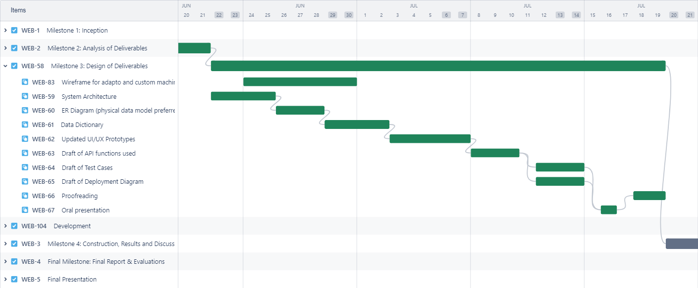
Figure 47: Gantt Milestone 3

Figure 48: Gantt details

